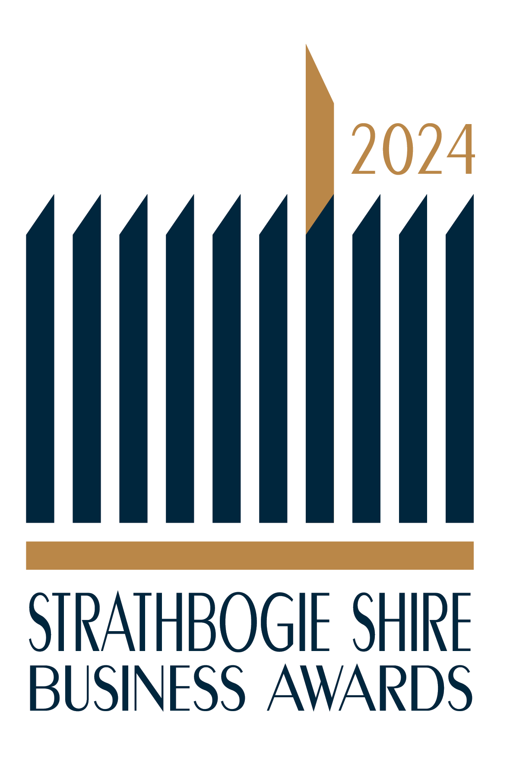
2024 Strathbogie Shire Business Awards.

Nomination Form – closing date Friday 10th May
This is your opportunity to nominate a business based in the
Strathbogie Shire that provides excellence in the following award categories,
please see the criteria listed overleaf.

This nomination form can also be completed online at www.visiteuroa.org.au/business-awards

Please tick or circle the category you are nominating the business for
□ | Service Excellence Award
□ | Tourism Excellence Award
□ | Employee Excellence Award
□ | Excellence in Agriculture
□ | Youth Recognition/Apprenticeship Award
□ | Small Business Excellence Award
□ | Large Business Excellence Award
Your name
Your phone |  | Email
Name of business
Contact person
Business address
Business phone |  | Email
Business website
Why are you nominating this business?

Please return the completed form to one of the following by Friday 10th May:
- Online: www.visiteuroa.org.au/business-awards
- Email: business.euroa@gmail.com or hello.gonagambie@gmail.com
- Post: Go Nagambie, PO Box 71, Nagambie 3608
- Post: EUROA CHAMBER P.O. Box 322 Euroa, 3666
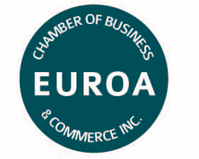
2024 Strathbogie Shire Business Awards is proudly brought to you by:

This nomination form can also be completed online at www.visiteuroa.org.au/business-awards

Please note: the business awards is not a popularity contest, the number of nominations a business receives will not influence the judging process.
The judges are independent and do not live in the Strathbogie Shire region.
The judge’s decision is final

Strathbogie Shire Wide 2024 Business Awards -
Award Criteria
1. Service Excellence Award (judged by secret shopper)
Recognises businesses that deliver outstanding customer service. Businesses are required to show consistent exceptional service and professionalism, demonstrating how they manage, monitor and measure customer expectations, satisfaction and retention. Open to all Industries.
2. Tourism Excellence Award
Recognises the ongoing effort required to attract visitors to the Strathbogie Shire region. This award includes providing quality accommodation, tourist attractions, events & festivals and/or food & beverage services that attract tourists. Open to all tourist attraction businesses, hospitality businesses and organisations in the Strathbogie Shire area as well as all businesses that target and attract tourism Markets.
3. Employee Recognition Award
Recognises employee excellence. This award is for those going above and beyond. The employee must be currently employed by the business and have worked for the same business for at least the past six months. They may excel in areas such as teamwork, customer service, leadership and mentoring, and/or knowledge of the relevant industry. This category recognises the importance of up-skilling employees, and how important employees are to the future needs of their employer’s business. Open to all employees and apprentices. Open to all industries.
4. Excellence in Agriculture [NEW]
Recognises businesses within the agriculture sector, delivering quality produce, standards and services around the shire and beyond. This award also recognises the sustainability practices and quality products of the operation. Open to all agricultural businesses within the Strathbogie Shire.
5. Youth Recognition / Apprenticeship Award [NEW]
Young people are valuable members of our community. They offer unique perspectives, talents and vibrancy which benefit the broader communities in our region. Young people often face challenges that require resilience, creativity and positivity and they demonstrate strengths
and abilities to overcome them. Youth Recognition Awards - where young people are recognised, celebrated and honoured for their outstanding actions in improving their communities, self and securing their futures.
6. Small Business Excellence Award
Recognises business excellence in delivering quality products and services to our community and beyond. Businesses are required to provide evidence of consistent exceptional service and professionalism, demonstrating how they manage, monitor and measure customer expectations, satisfaction and retention. The award also recognises the progression, determination, teamwork, resilience and sustainability of the area’s businesses. Open to businesses employing 1 to 20 people. Open to all industries.
7. Large Business Excellence Award
Recognises business excellence in delivering quality products and services to our community and beyond. Businesses are required to provide evidence of consistent exceptional service and professionalism, demonstrating how they manage, monitor and measure customer expectations, satisfaction and retention. Also recognises the innovation, progression, determination, teamwork, resilience and sustainability of the area’s businesses. Open to businesses employing 21 or more people. Open to all industries.

